**How To Register As Developer On Apple**

You need an Apple Id before you Register either for a *Free Developer Account* or *A Membership Account*.

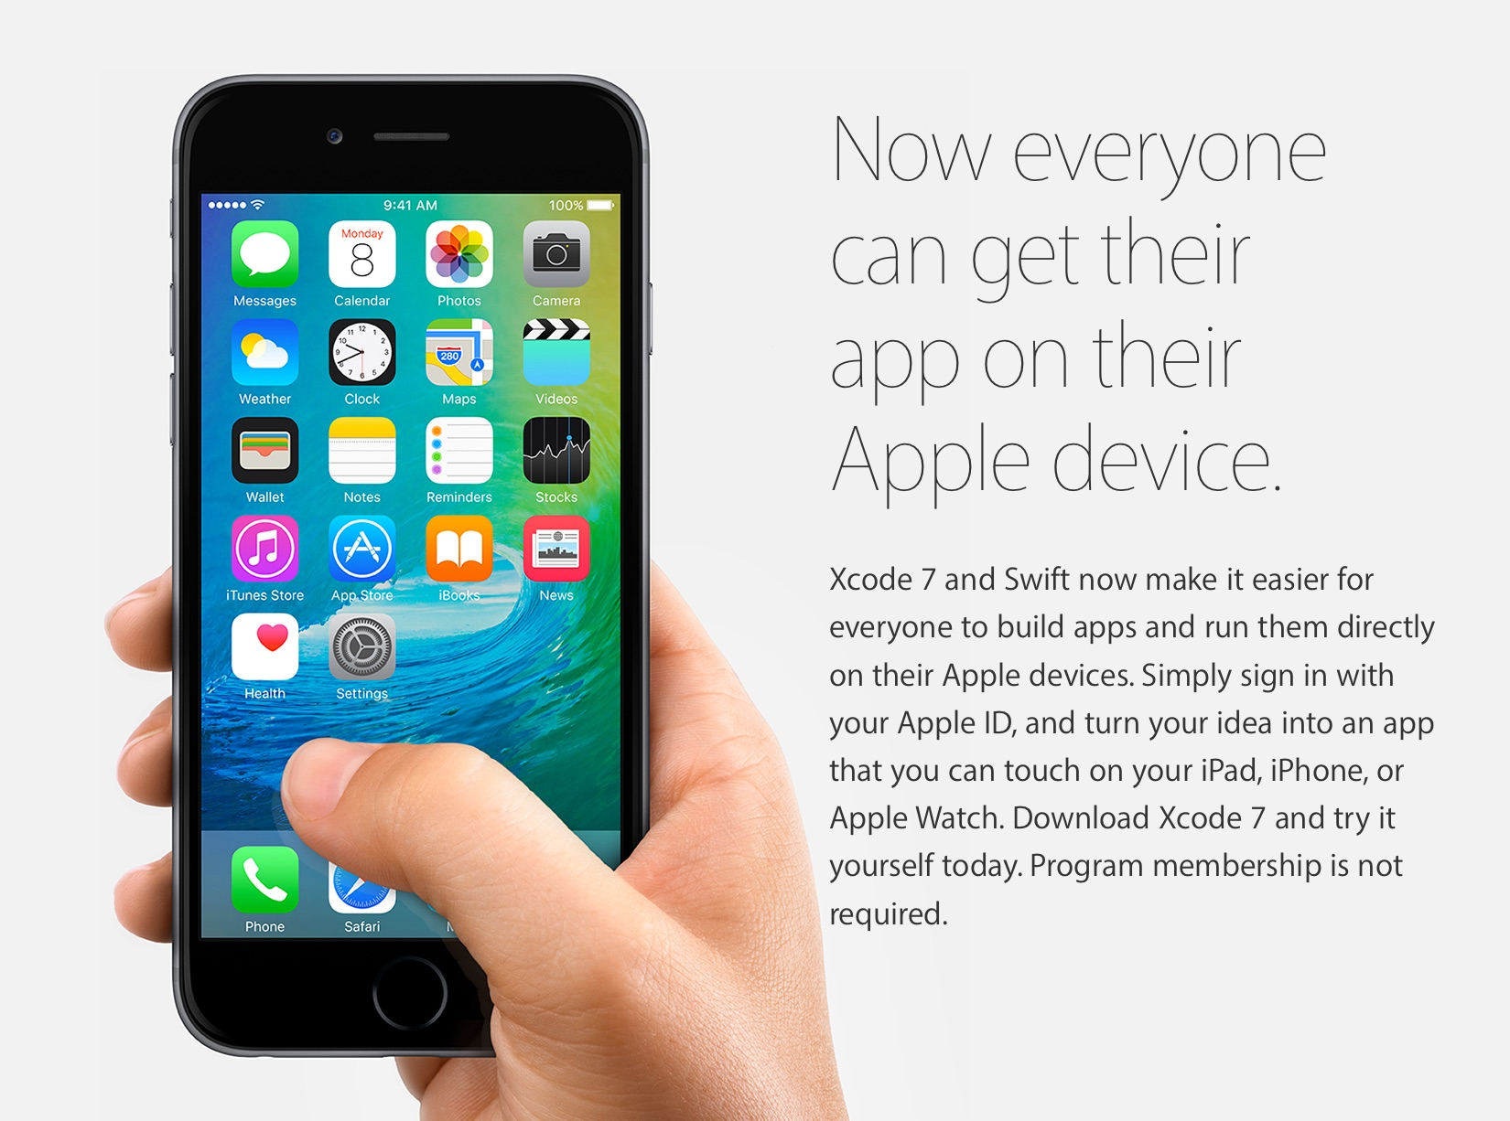

**Steps To Create A New Apple ID:**

* Sign In to developer.apple.com.
* Under Account option, one can Create a New Apple ID.
* Click on Create Apple ID button.

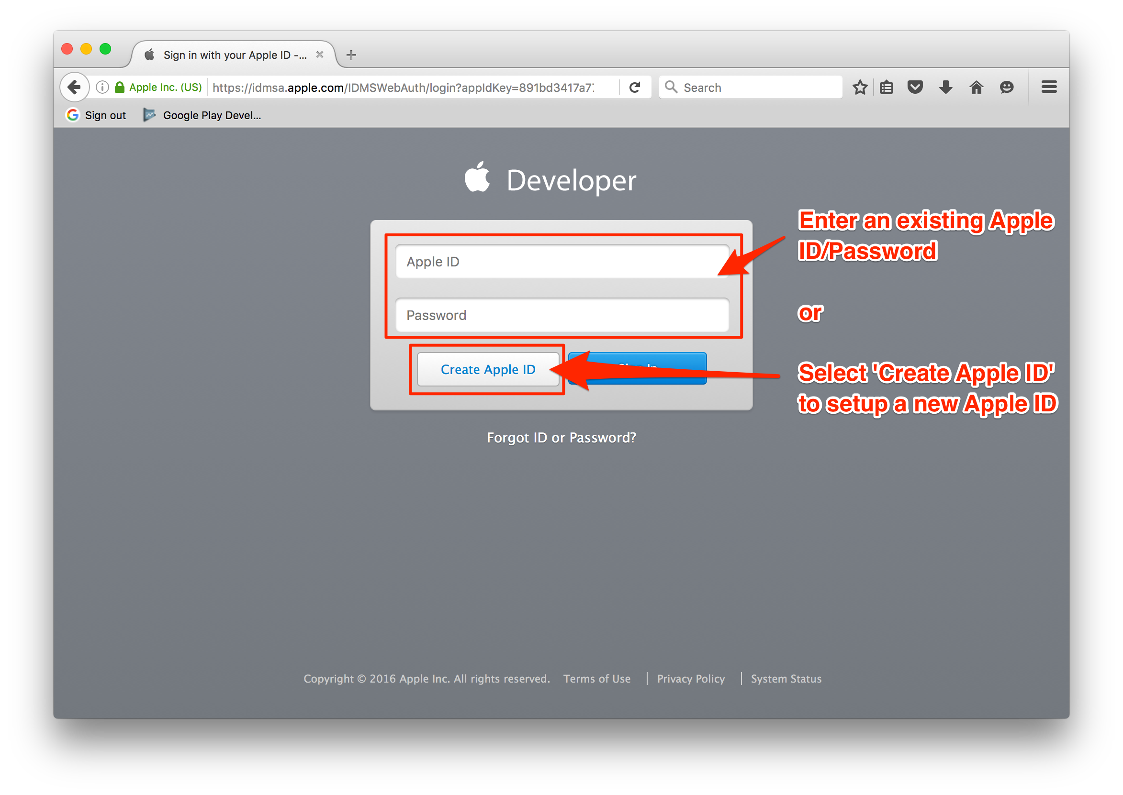

* Fill out the required information.

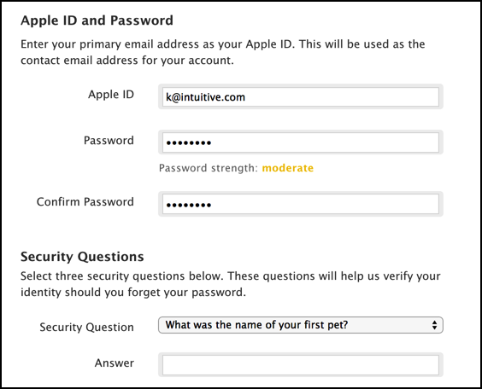

* Click on Continue button.

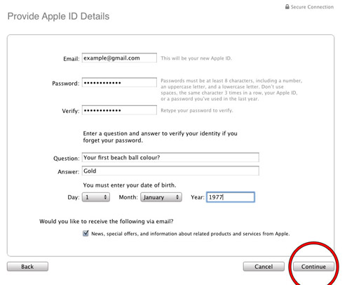

* Enter the Verification Code for verifying your email address to Create your New Apple ID.

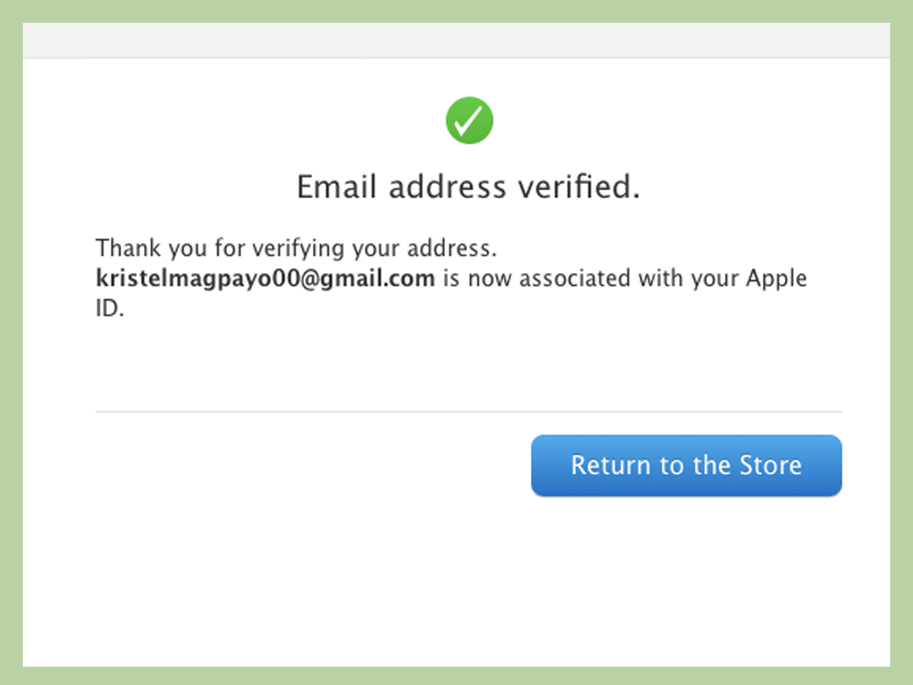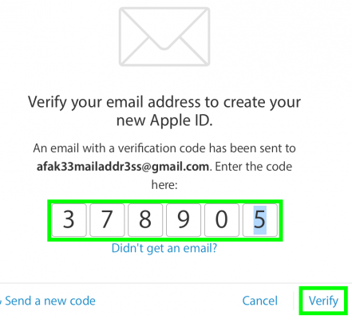

**Enroll For Free Apple Developer Account**

* Visit developer.apple.com.
* Click on Account icon.
* Enter your Apple ID and password if you have one and click on Sign In and you will reach an Apple Developer Agreement page.

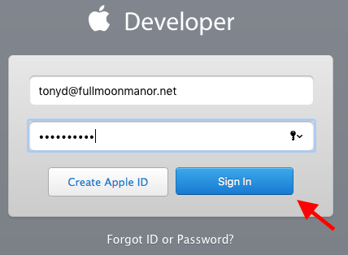

Read the information provided and then mark the first Check Box rendering that you accept the Agreement and click on Submit. It will convert your Apple Id into immediate access to Free Apple Developer Account.

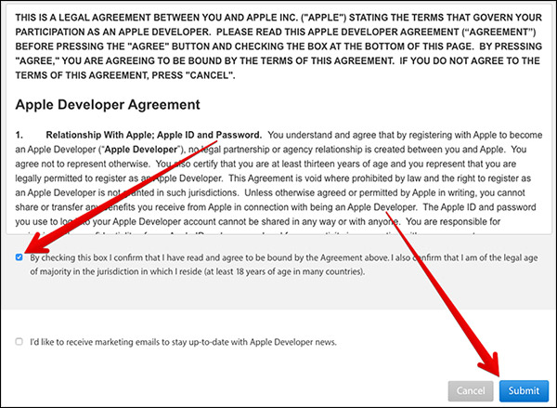

* But if you don’t have the one, then create one.
* Now, log in with your newly created Apple ID and you will reach the Apple Developer Agreement page. Just follow the same instructions as provided above to have a limited developer privileges.
* You will see SDKs and Bug Reporting on the page.

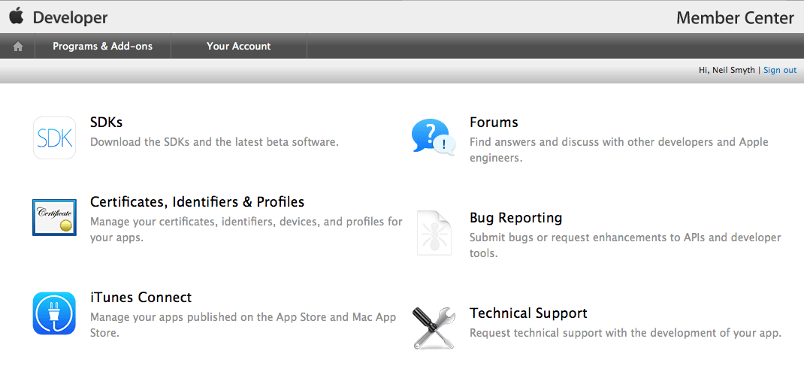

* If you click on SDKs and then on different Platforms like iOS, OS X, watchOS, tvOS you will notice that it will grant you a restricted access developer accounts as you have not paid for it.

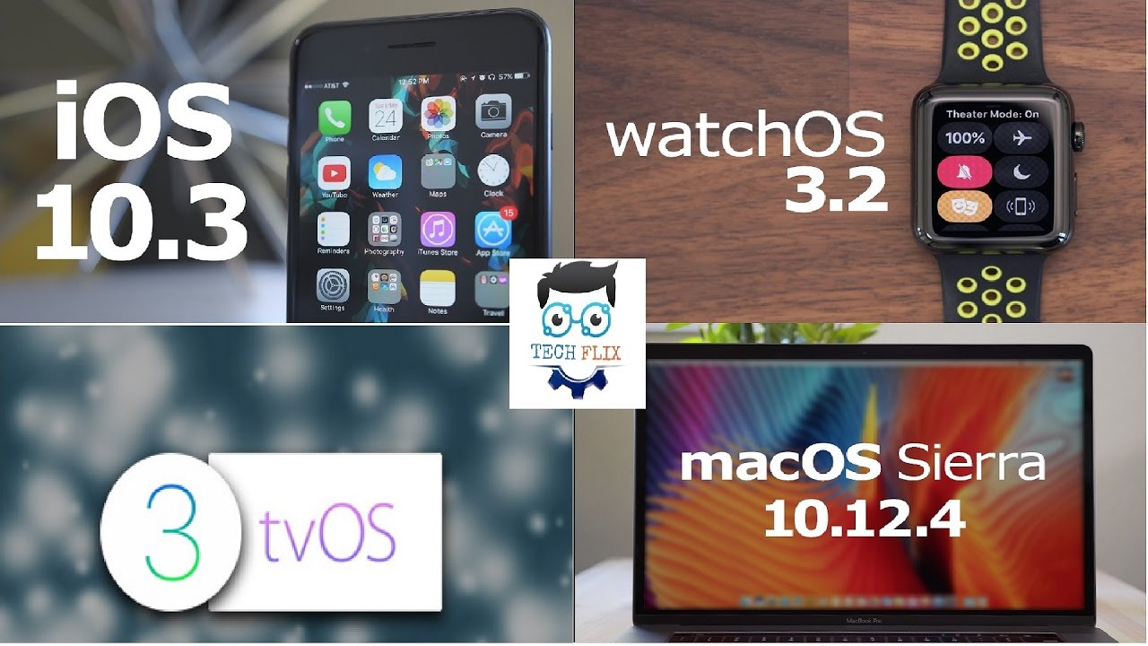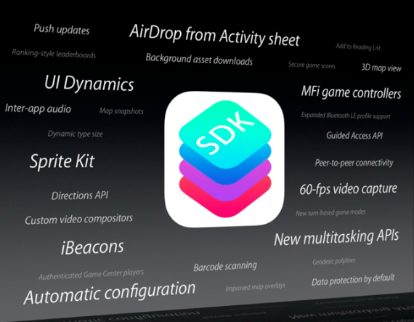

* But you can link this to Xcode and deploy your apps to iOS devices and Apple tvOS.

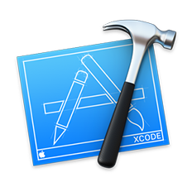

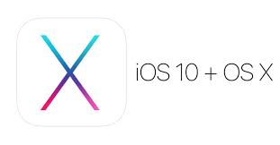

* For this, launch Xcode first, then go to the Xcode option, a popup will appear, click on the Preferences option. Click the Account step, then Add Apple ID option by clicking the plus(+) sign. Add the same ID and Password and click Sign In button for using to Xcode play apps on your iOS devices.

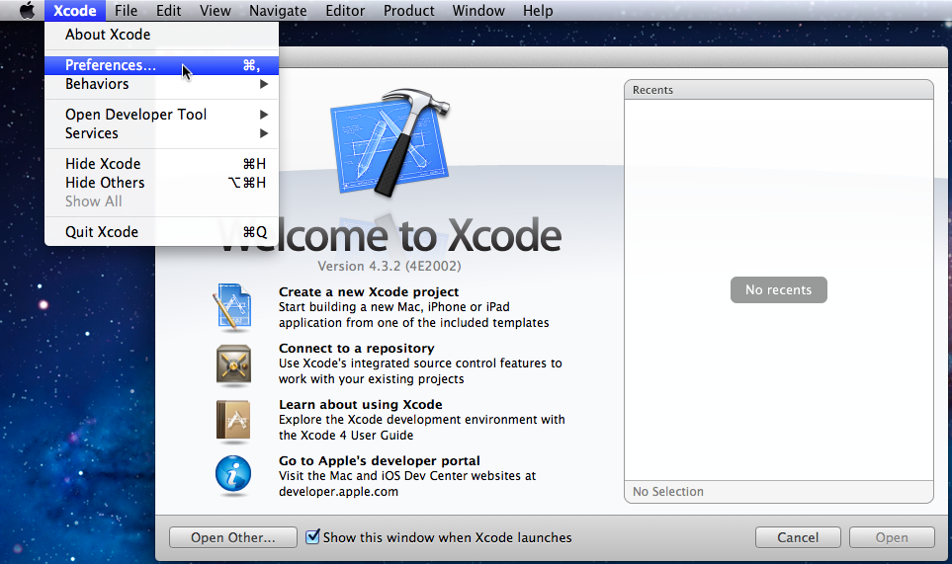

**Enroll For Apple Developer Program Membership**

If you want to have a complete access to the Apple Developer Program facilities then you will need to opt for a membership.

**Steps *For Holding The Membership:***

* Visit developer.apple.com.
* Click on Developer Program icon.
* Then click on Enroll option present at the top of the Developer Program Membership page.

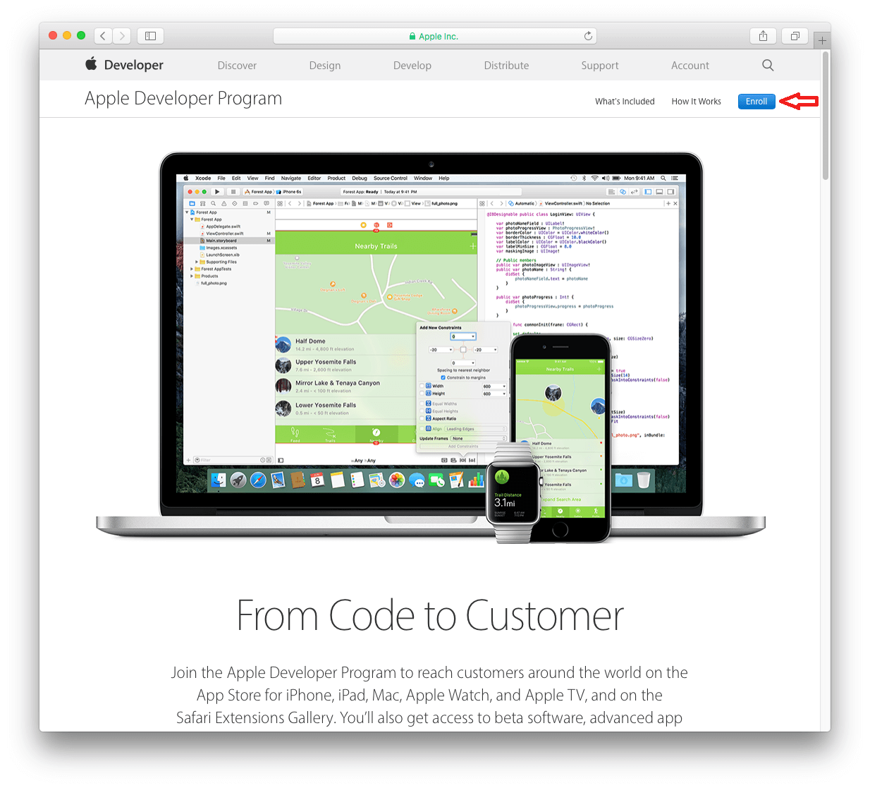

* The page will appear with a title naming “What You Need To Enroll”. Here, click on Start Your Enrollment button at the bottom.

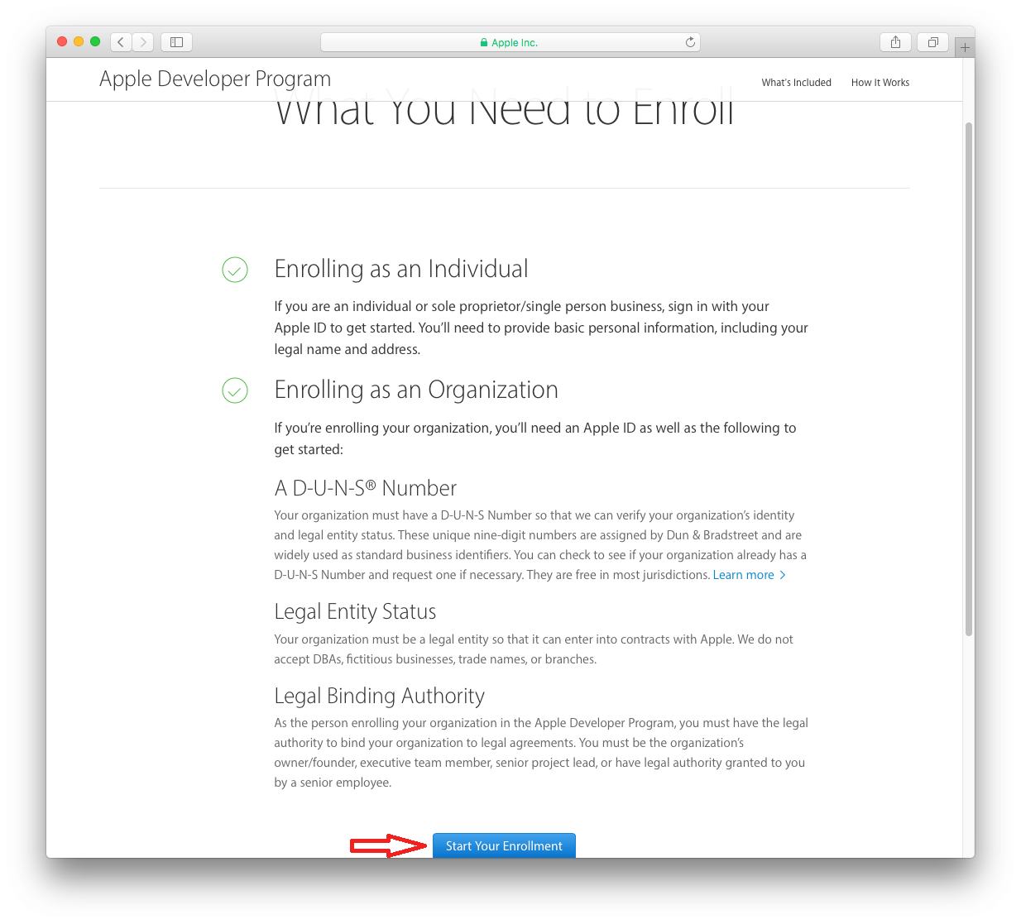

* You will enter the login page, Enter your Apple ID and password if you have one and click on sign-in, But if you don’t have one then just Create a New Apple ID as mentioned above and Sign In with it.
* Once it is created, Sign In with your ID and Password, again you will reach an Apple Developer Agreement page.

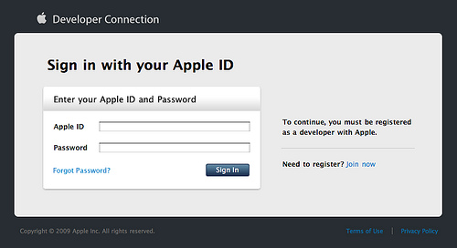

* Read the information provided and then mark the first Check Box rendering that you accept the agreement and click on Submit.
* On the Apple Developer Program Enrollment Page, Select your Entity Type whether you want to enroll as an Individual/ Sole Proprietor/Single Person business or a Company/Organization or as a Government Organization, then click on Continue.

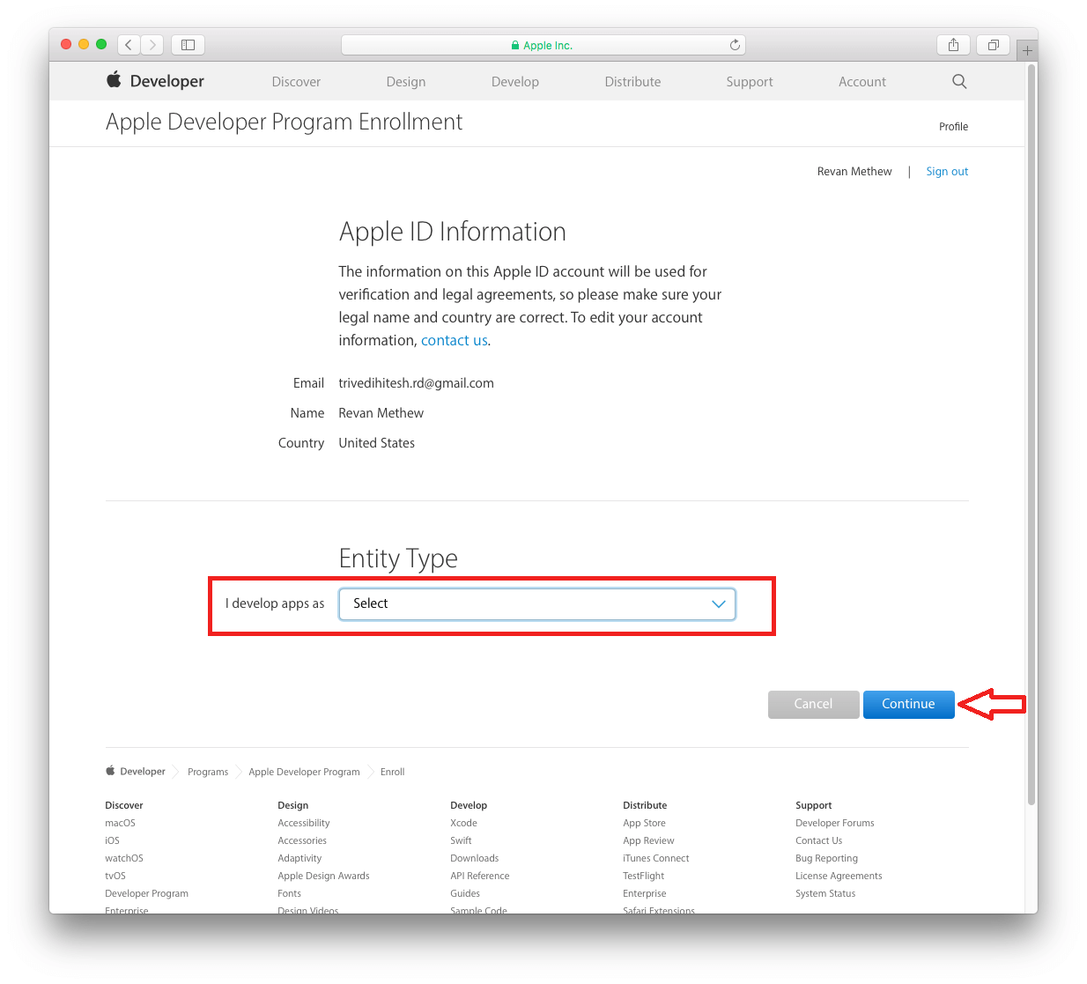

* Put on the information asked and then again click on the Check Box provide to accept the Apple Developer Program License Agreement and click on Continue.
* An another page will appear where you need to click on Purchase button, here, you can also click on Check Box to select Automatic Renewal option.

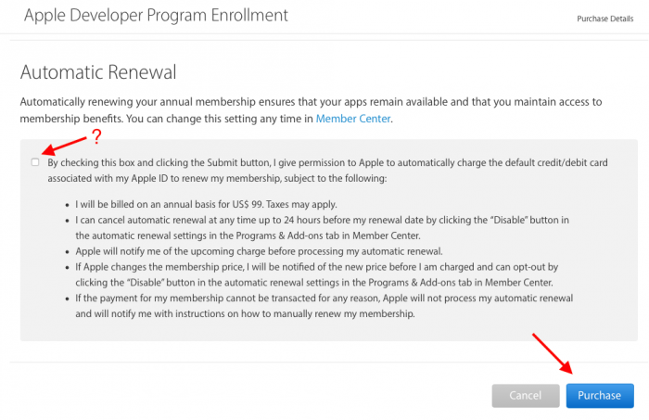

* After this, enter your Billing information and click on Continue.

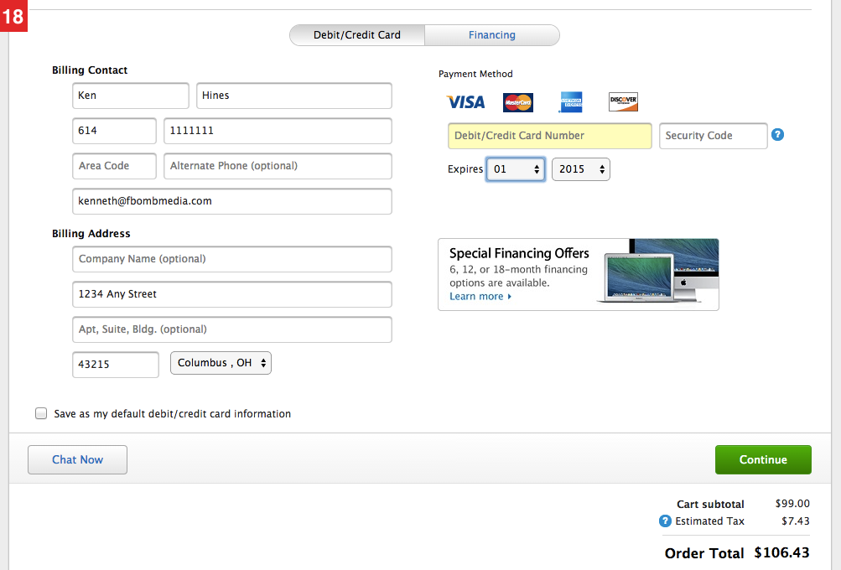

* The Membership Purchasing page will get open, click on Place Order Now option to complete your purchase. It will impart you a whole access to Apple Developer Program.

